Hiking Club Summer Trip

Austria 2007

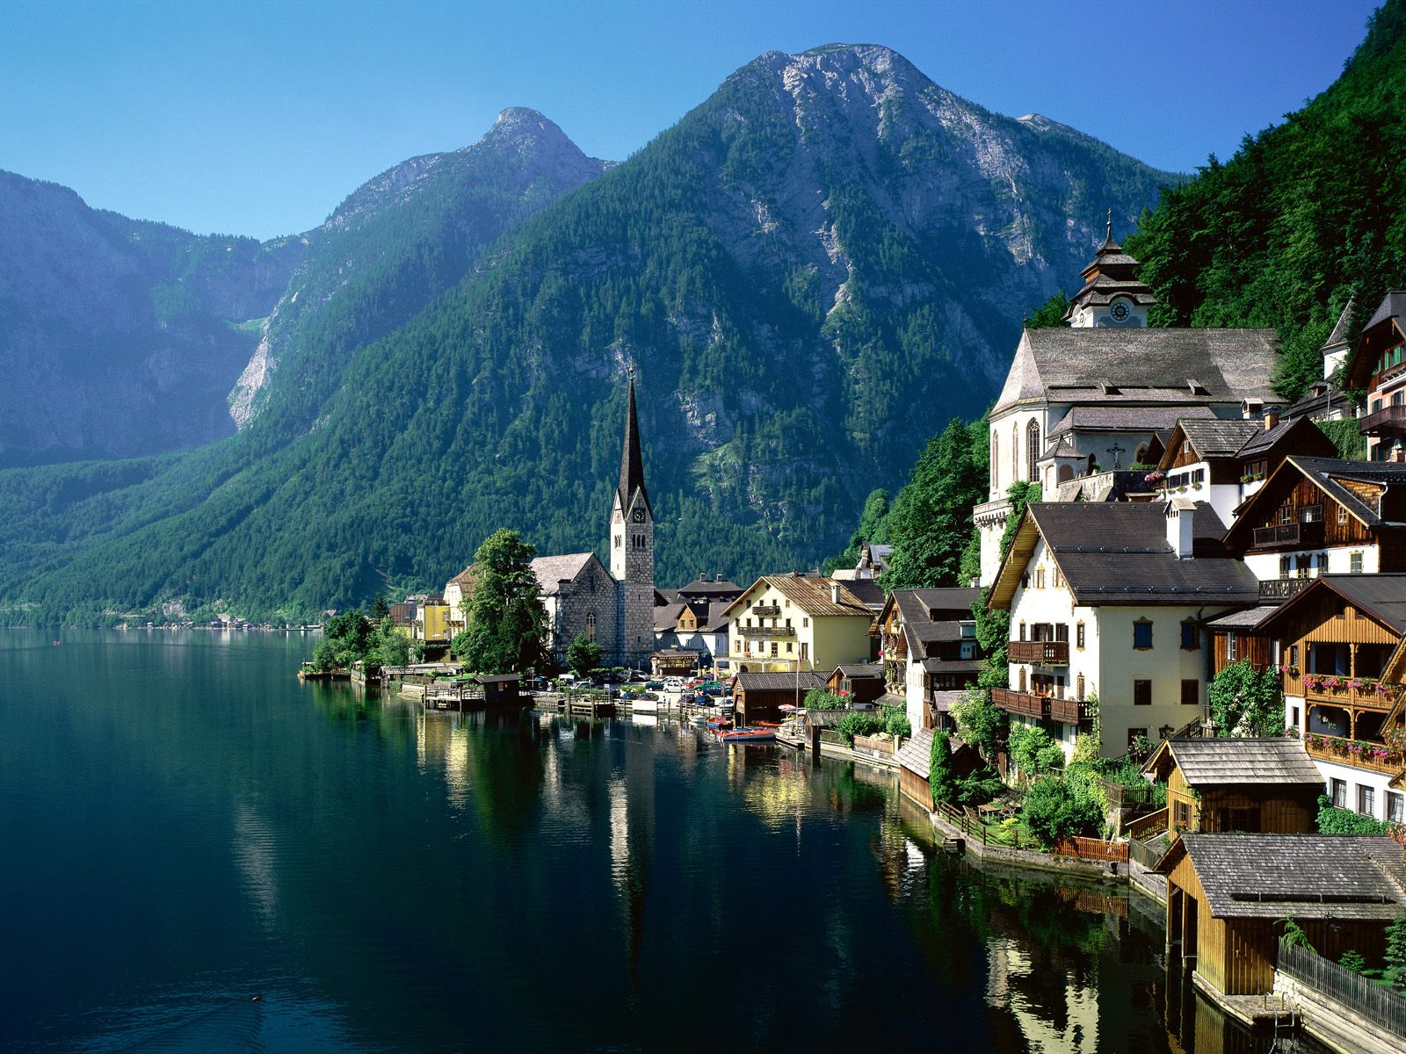

Monday 18th – Friday 29th June 2007

For our summer trip this year we’re going to the beautiful Salzkammergut region of Austria, about two hours away from Salzburg. During our 11-night stay there will be plenty of time for hiking in the stunning Dachstein mountains, swimming in the lake, sitting in traditional Austrian beer gardens or perhaps visiting caves, salt mines or the city of Salzburg.

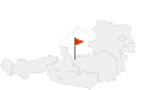
We will stay at a campsite in the village of Hallstatt (508m above sea level), a UNESCO World Heritage site nestled between the foot of the Dachstein mountains and the Hallstatt Lake.

Travel Itinerary

Monday 18th June 2007

02.00 Leave Swansea on a National Express coach to Gatwick airport.

07.25 Arrive Gatwick North Terminal and check in for flight BA2652 to Salzburg.

  - Depart Gatwick

13.50 Arrive Salzburg airport and catch the airport bus** to the main bus and train station.

15.15* Catch a bus to Bad Ischl

16.38* Arrive in Bad Ischl

17.20* Catch a train from Bad Ischl to Hallstatt train station

17.48* Catch the boat across the lake to Hallstatt

Walk through Hallstatt to the campsite.

Friday 29th June 2007

08.14* Depart Hallstatt on the train to Bad Ischl

08.41* Arrive Bad Ischl

09.35* Depart Bad Ischl on the bus to Salzburg

10.57* Arrive Salzburg and catch the airport bus** from the bus station to the airport.

Arrive at the airport and check in for flight BA2653 to London Gatwick

14.50 Depart Salzburg

16.00 Arrive Gatwick

17.10 Catch the National Express back to Swansea

22.50 Arrive Swansea

*According to the current timetables (Nov 06) – these times may change.
**The Salzburg Airport bus goes every 10 minutes and takes 20 minutes.
Tuesday 19th – Thursday 28th June 2007

Hiking

We can do as much or as little hiking as we want once we’re in Austria. There are plenty of opportunities to go for all day hikes or shorter wanders in the area.

Some longer hikes could include:
- Walking to various peaks on the Dachstein plateau (photo below, right), such as the Taubenkogel at 2300m.
- Plassen, a challenging hike to a 1953m peak.
- Around the Gosaukamm, a range of jagged peaks a short bus journey away from Hallstatt. (Photo below, left)

Shorter walks could include:
- The Glacier Garden – pools and waterfalls running down the mountainside.
- Walks along the side of the lake.
- Wanders in the pine forests.

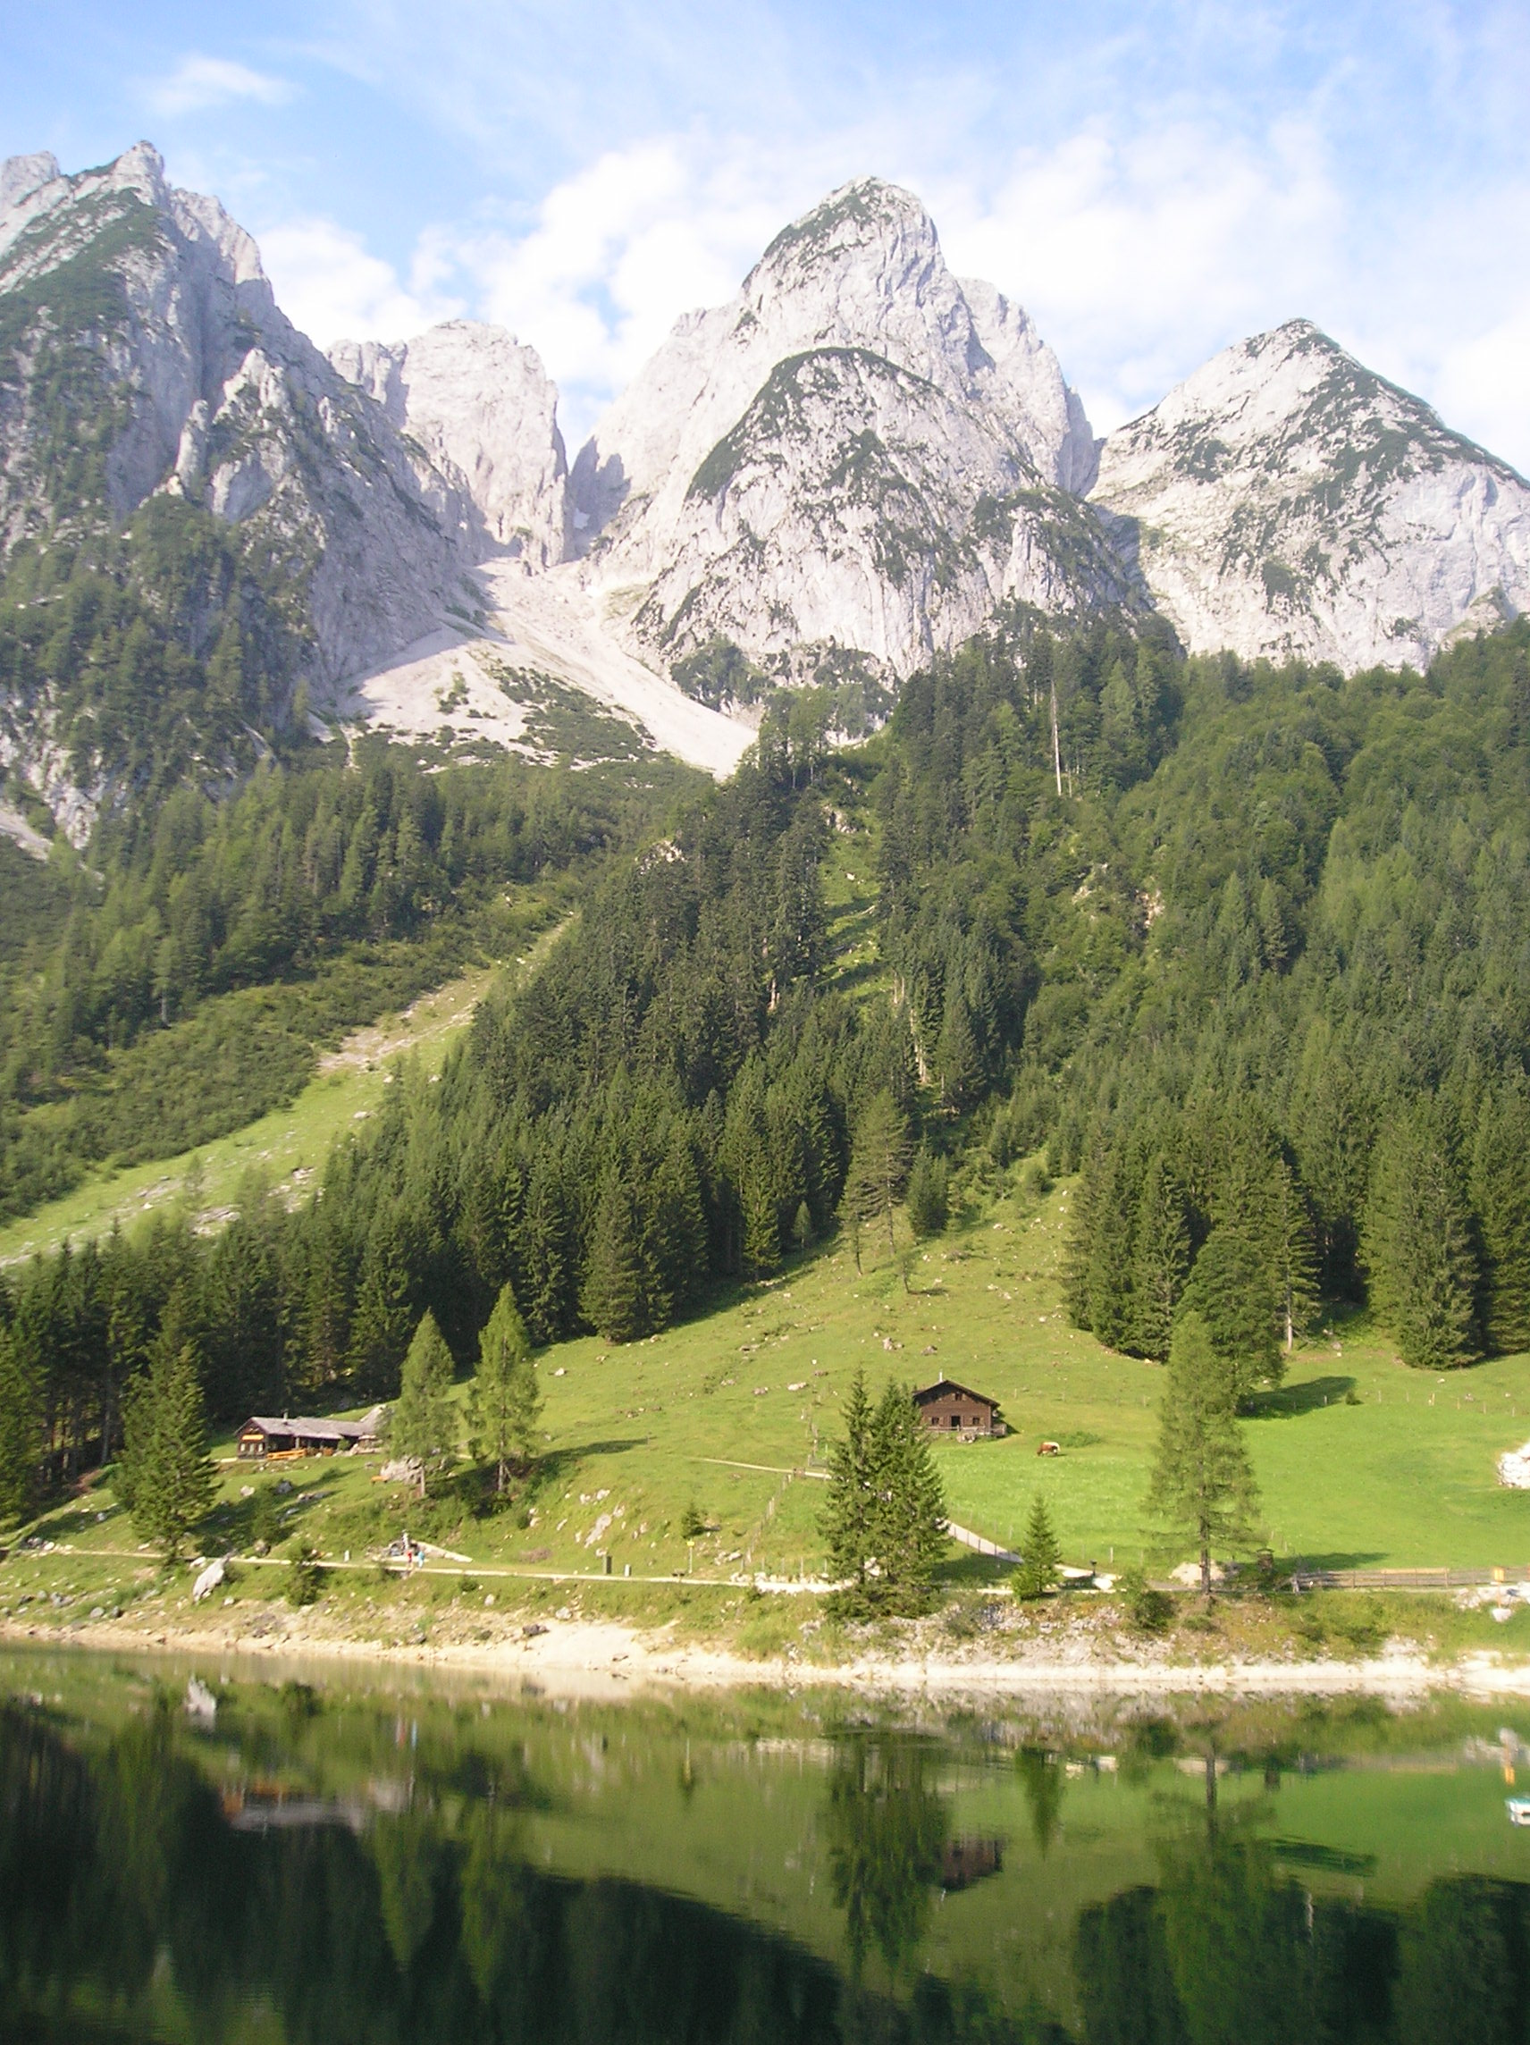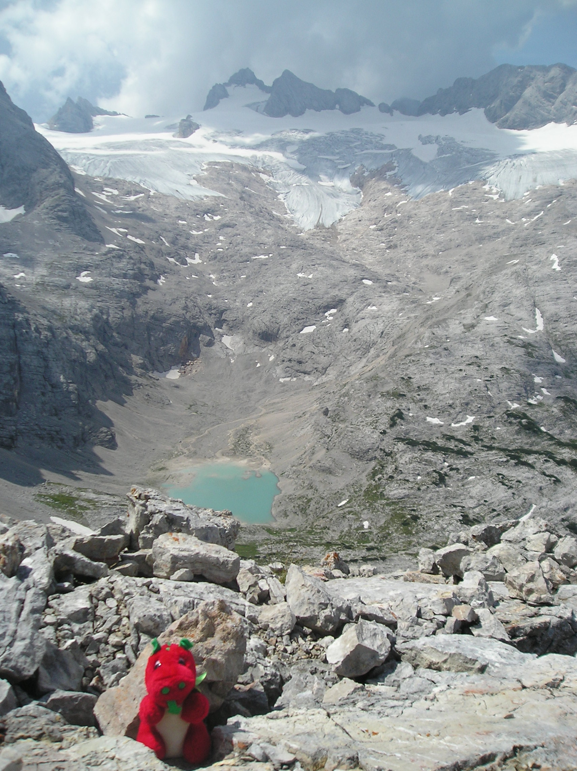

Days off from hiking

There are plenty of things to do on days off from hiking as well:
- The stunning Ice Caves and Mammoth Caves can be reached by cable cars from Obertraun, the next village along the lake.
- Hallstatt’s salt mines are also worth visiting – the wooden miners’ slides are a highlight of the tour!
- Bad Ischl, the "Kaiserstadt" (Emperor’s town) is about 30 minutes away by train.
- The beautiful city of Salzburg is just an hour and a half’s bus journey away from Bad Ischl and offers a castle, beautiful churches and a Sound of Music tour!
Campsite

The campsite we’ll be staying at has hot showers, a kitchen with fridge, microwave, water boiler, sinks and washing machines. It’s about 100m away from the lake where we can go swimming and 250m away from a supermarket.

Hallstatt

Hallstatt caters very well for tourists with lots of beer gardens and very reasonably priced restaurants for the occasional meal out. In general, eating out in Austria is much cheaper than in the UK.

Hallstatt has a rich history of saltmining, dating from around 5000BC. It has given its name to “The Hallstatt Period”, which is the Early Iron Age from 800BC-400BC. The body of a fully preserved prehistoric miner from around 300BC was found in Hallstatt in 1734 and is known as the “Man in Salt”.

Swimming in the Hallstättersee (Hallstatt Lake) is an unforgettable experience due to the tranquility of the lake combined with the magnificent surrounding

mountains.

See www.hallstatt.net for further information!
Cost

At the moment (Nov 06), flights cost £85 return.

The National Express coach is £45 return.

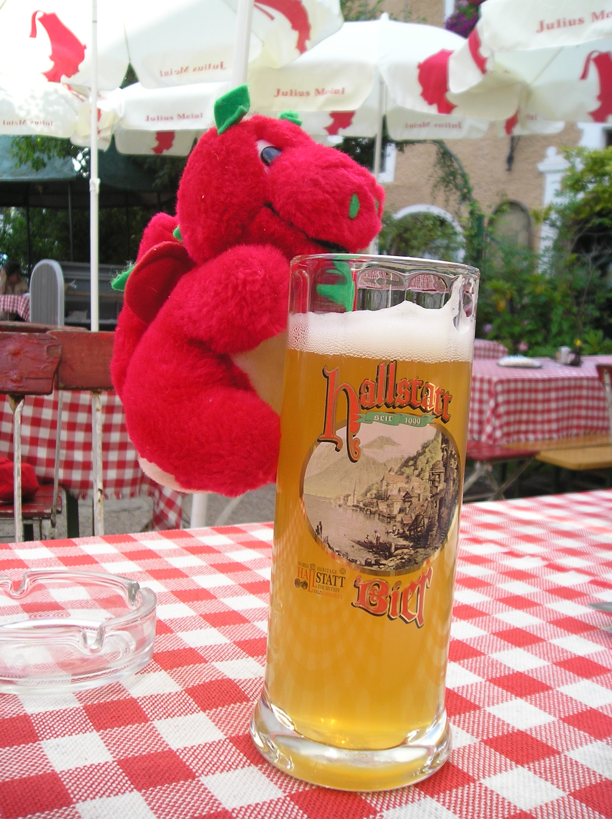

Transport between Salzburg and Hallstatt should cost around €30 (about £20).

Accommodation should cost around €70 (about £47), based on 3-man tents.

A deposit of £30 is required by 31/01/07, which will go towards accommodation.

Overall, the trip should cost around £200-£250, depending on how much you want to eat out and whether you visit the caves, etc.

We can help you book your flights and coach tickets. It’s best to book flights as soon as possible as the flight costs will increase nearer the time.

Tents and trangias would be useful, but you won’t need any special equipment.

Remember to buy travel insurance – it’s absolutely essential and isn’t expensive!

The trip promises to be an unmissable experience – hope to see you there!

